employee (ID, person_name, street, city)
works (ID, company_name, salary)
Figure 1
- (20%) Consider the employee database with two relations in Figure 1.
- Write a function avg_salary that takes a company name as an argument and finds the average salary of employees at that company.
Ans:
Create function avg_salary(company_name varchar(20))
returns interger
begin
declare avg_ interger:
select avg(salary) into avg_
from works
where works.company_name=company_name;
return avg_;
end
- Write an SQL statement, using the avg_salary function, to find companies whose employees earn a higher average salary than the average salary at“FirstBank”.
Ans:
Select distinct company_name
From works
Where avg_salary(works.company_name)>avg_salary(‘FirstBank’);

- (20%) Design a database using the ER-diagram for an airline. The database must represent the information of each flight (航班), including its flight number and schedules (起飛降落的日期時間). The database also needs to keep track of customers and their reservations on individual flights, including the status and seat assignments. (Design the proper entity sets and relationship sets. For each entity set, represent the proper primary key and attributes.)

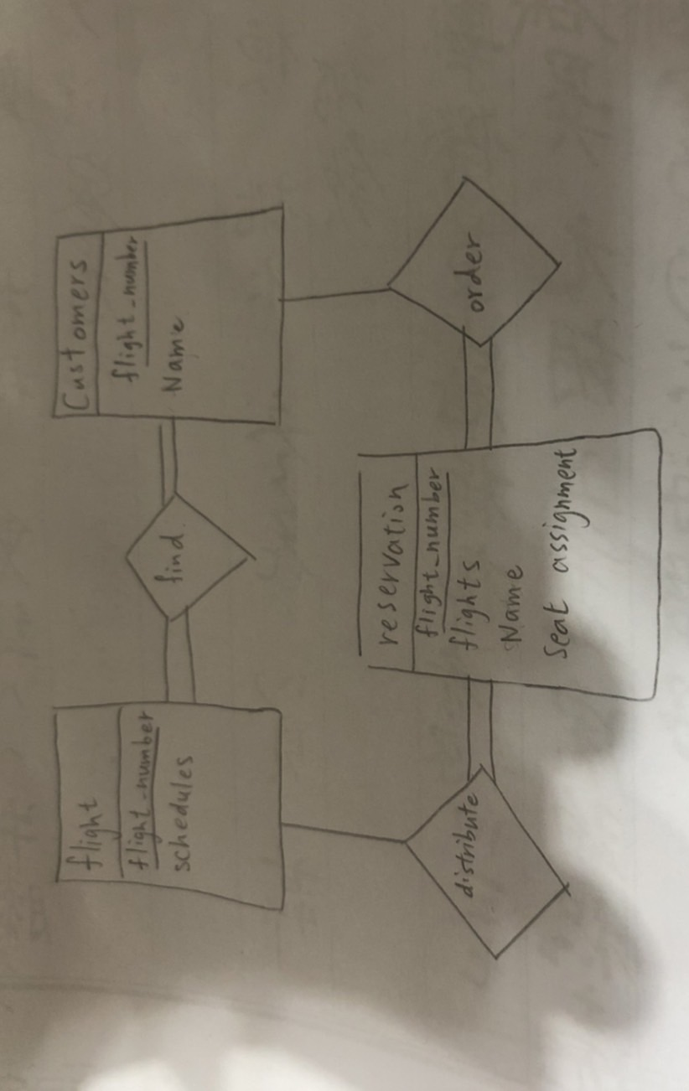
- (20%) Construct appropriate relational schemas for the E-R diagram in Figure 2. For each relational schema, represent the proper attributes and primary key.
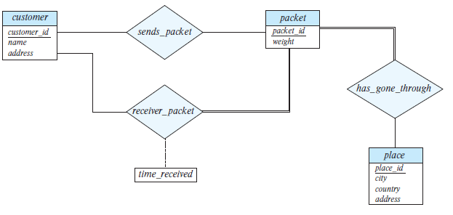
Figure 2
Ans:
sends_packet( packet_id, customer_id)
receiver_packet(packet_id, customer_id, time_received)
has_gone_through(place_id, packet_id)

- (20%) List two nontrivial functional dependencies satisfied by the relation in Figure 3. Explain your answer.
A | B | C
a1 | b1 | c1
a1 | b1 | c2
a2 | b1 | c1
a2 | b1 | c3
Figure 3

Ans:
C->B
B不屬於C ,但可以透過C推出唯一的B
A->B
B不屬於A ,但可以透過A推出唯一的B

- (20%) Consider the schema R = (A, B, C, D, E, G) and the set F of functional dependencies as follows:
{AB → CD, B → D, DE → B, DEG → AB, AC → DE}.
- Prove that AB is not a superkey.
- Prove that DEG is a superkey.
Ans:
- DEG → AB → CD 因為AB具transitively dependent 所以不為superkey
- DEG → AB , DEG →CD 且 AB-\-> DEG, CD-\-> DEG 所以DEG是superkey
Note: Please submit your homework in a single PDF file to TronClass by 12/20/2023 11:59pm.

